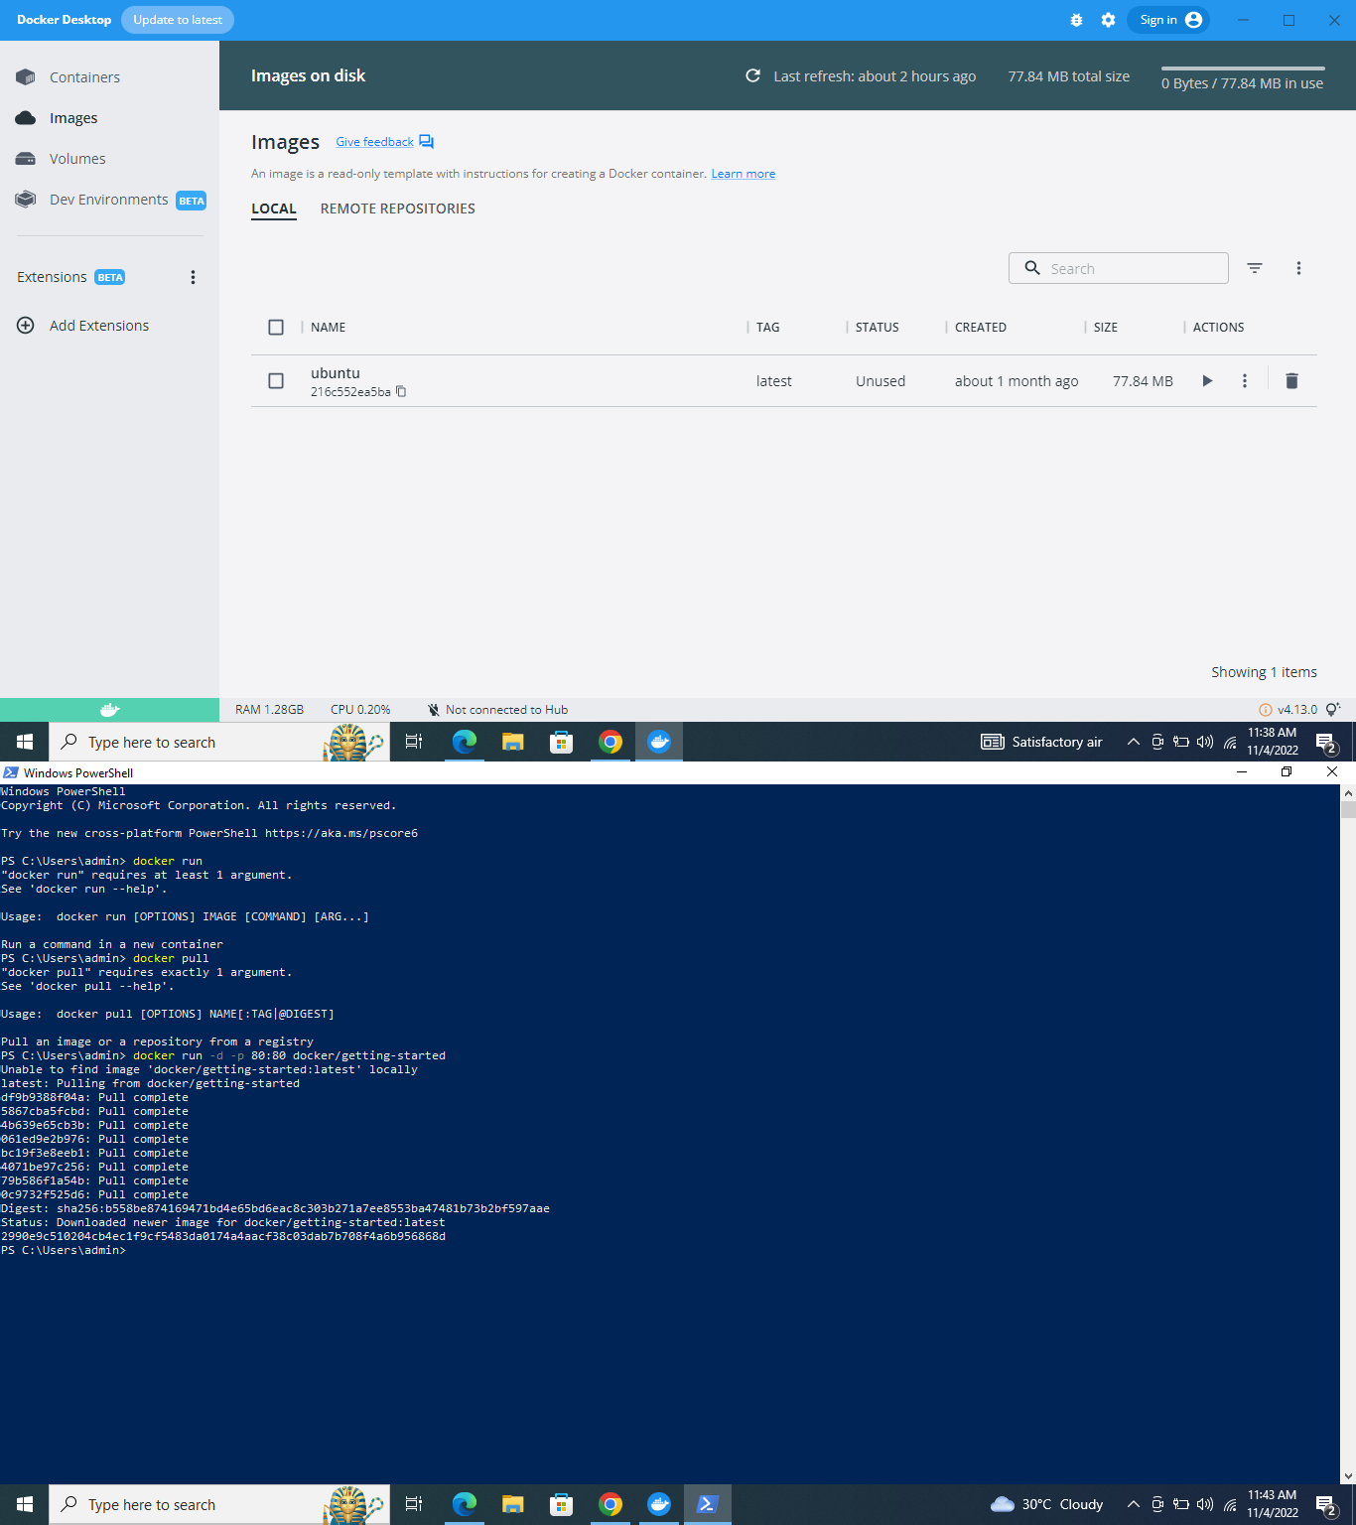Setting Up Of Environment

**Docker CLI Installation**

TEAM ID: PNT2022TMID39742